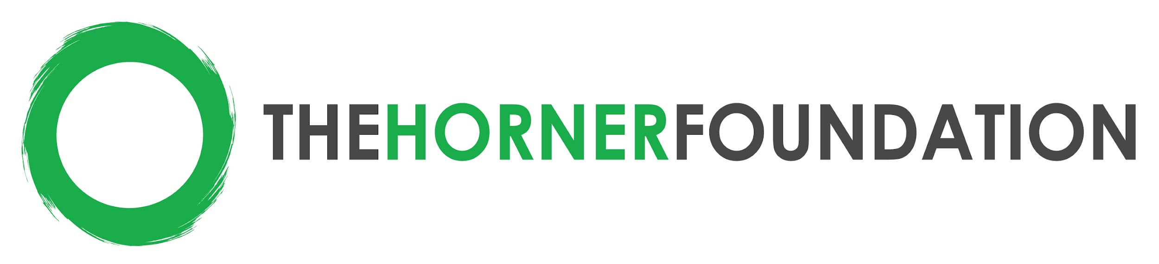

2024-2026 Funding Criteria: Out of School Time (OST) STEM Programs
Philadelphia, Pennsylvania

Targeted Grant Size: up to $37,500 per year for 2 years

Strategy: Since 2013, The Horner Foundation has supported Out of School Time programs working directly with underserved youth aged 10-19 in the City of Philadelphia. For our 2024 funding cycle, we will focus on out-of-school time STEM programming. More information about the application process can be found at: https://www.thehornerfoundation.org/

Types of Organizations that should apply:
- Nonprofit organizations serving youth in Philadelphia County
- Emphasis on underserved youth aged 10-19 (middle and high school)
- Minimum organizational revenue at least $150,000 USD in most recent fiscal year
- Operating as a 501(c)3 for a minimum of three years
- Demonstrated strong staff leadership and management capacity
- Organization should serve youth in on-going OST programming (as opposed to one-time events)
- Organization must have interest in improving their capacity to collect, understand, and use data for ongoing improvements and stronger results

Funding Focus
STEM (Science, Technology, Engineering, and Math): The intention of this funding focus is to inspire members of the next generation to pursue careers in the science, technology, engineering, and math sectors through programming delivered in an inclusive learning environment.

- The program may include coding, robotics, entrepreneurship, engineering, and other STEM-related OST programming aimed at equipping youth with the tools necessary to thrive in a tech driven society.
- This funding focus also includes programs that encourage leadership training and career preparation for young tech leaders in underserved communities.

Out of School Time (OST), is a supervised program that young people regularly attend when school is not in session (www.cdc.gov/healthyschools/ost.htm

