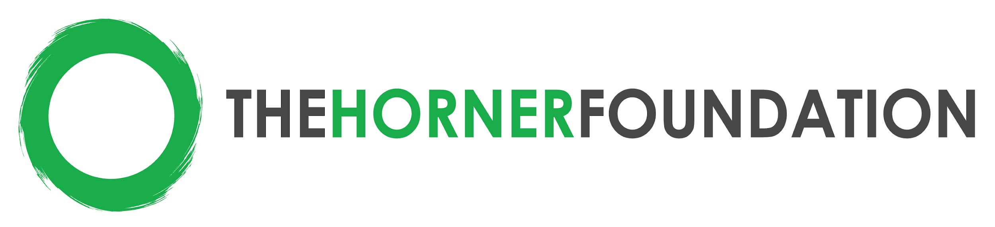
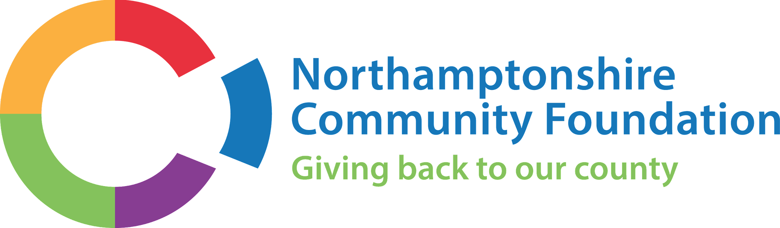

2022-2024 Funding Criteria: Healthy Youth Northamptonshire
Towns of Corby & Kettering, Northamptonshire, England

Targeted Grant Size: $40,000-50,000 USD/ £29,500-36,900 GBP over 2 years

Strategy: The intention of the Foundation’s work in Northamptonshire is to focus on the Towns of Corby and Kettering in order to improve outcomes for young people and young mums. Existing programs and services already working in these towns, as well as other organizations looking to expand their reach into these under-resourced regions are encouraged to apply. Projects should be well rooted in community need, with an emphasis on service user feedback informing and refining the service models. Through this strategic funding, it is our hope that Corby & Kettering will be models of sexual health & antenatal education deeply rooted in the community. If you match the criteria listed below, we encourage you to submit a letter of intent (LOI). More information about the LOI and application process can be found at: https://www.thehornerfoundation.org/

Types of programs that should apply:
- Charitable organizations working with underserved youth aged 11-25
- Organizations working in the Towns of Corby & Kettering, Northamptonshire
  - Organizations already working in these cities, or wishing to expand services into Corby and/or Kettering
- All successful grants will be required to monitor outcomes in a specific way, so that data can be compared for the region

Two Funding Focuses:
- Sexual Health & Education for Young People
- Health, Education & Social Supports for Young Mums

Example projects may include, but are not limited to:
- Prevention: Pregnancy education, sexual education
- Support: Antenatal and parenting education
- Education: Sexual and reproductive health workshops to help individuals make the best choices for sexual wellness
- Gender Equity and Education: with a focus on people of all genders, orientations, identities and abilities

Reference: Northamptonshire Community Foundation Hidden Needs in Northamptonshire

